Module-4) Se - Introduction To DBMS
Introduction to SQL:

Theory Questions:

1. What is SQL, and why is it essential in database management?

SQL stands for Structured Query Language. It is a standard language used to communicate with databases.

---

What does SQL do?

SQL is used to:
1. Insert data into a database (using INSERT)
2. Retrieve data from a database (using SELECT)
3. Update existing data (using UPDATE)
4. Delete data (using DELETE)
5. Create tables and databases (using CREATE)
6. Manage database structure (using ALTER, DROP, etc.)

---

Why is SQL essential in database management?

- It acts as a bridge between the user and the database.
- Without SQL, you cannot interact with the database.
- It helps manage, filter, and analyze data easily.
- SQL is used in almost every relational database (like MySQL, Oracle, PostgreSQL, etc.)

---

In short:
SQL is crucial for working with databases. It's used in the backend of websites, apps, and software wherever data is stored or processed.

2. Explain the difference between DBMS and RDBMS.
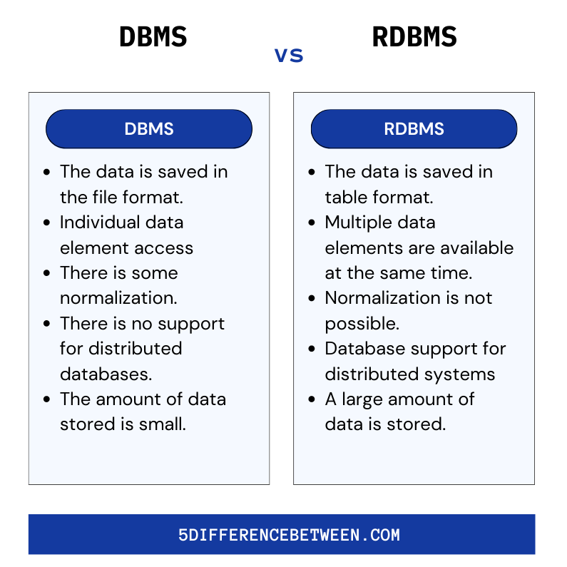

3. Describe the role of SQL in managing relational databases.
SQL (Structured Query Language) is used to manage and interact with relational databases.

Why it's important:
- Create and modify tables (DDL)
- Insert, update, delete, and fetch data (DML)
- Control user access (DCL)
- Handle transactions (TCL)
- Maintains data accuracy and security
- Works with all major RDBMS (like MySQL, Oracle)

Example:
SELECT * FROM users; → fetches all data from the "users" table.

4. What are the key features of SQL?

1. Data Querying
- Retrieve data using SELECT statements.
- Example: SELECT name FROM students;

2. Data Manipulation (DML)
- Insert, update, delete records.
- Commands: INSERT, UPDATE, DELETE

3. Data Definition (DDL)
- Create and modify table structures.
- Commands: CREATE, ALTER, DROP

4. Data Control (DCL)
- Control access to data.
- Commands: GRANT, REVOKE

5. Transaction Control (TCL)
- Manage transactions in a database.
- Commands: COMMIT, ROLLBACK, SAVEPOINT

6. Relational Data Handling
- Works with relationships (foreign key, primary key) in RDBMS.

7. Easy to Learn
- Simple syntax, English-like queries.

8. Platform Independent
- Works across all platforms and RDBMS (MySQL, Oracle, etc.)

2. SQL Syntax

Theory Questions:

- What are the basic components of SQL syntax?
1. Statements/Commands
- Core instructions like:
SELECT, INSERT, UPDATE, DELETE, CREATE, DROP

2. Clauses
- Add conditions to statements:
WHERE, ORDER BY, GROUP BY, HAVING

3. Expressions
- Perform calculations or return values:
price * quantity, salary + bonus

4. Predicates
- Test conditions:
WHERE age > 18, WHERE name LIKE 'A%'

5. Identifiers
- Names of tables, columns, databases, etc.

6. Operators
- Symbols to compare or compute values:
=, >, <, AND, OR, NOT

7. Functions
- Built-in operations:
COUNT(), SUM(), AVG(), MAX(), MIN()

8. Literals
- Fixed values:
'John', 100, '2025-01-01'

9. Semicolon (;)
- Ends an SQL statement.

Example:
sql
SELECT name, age FROM students WHERE age > 18 ORDER BY age;
- Write the general structure of an SQL SELECT statement.
*General Structure of an SQL SELECT Statement:*

sql
SELECT column1, column2, ...
FROM table_name
[WHERE condition]
[GROUP BY column]
[HAVING condition]
[ORDER BY column ASC|DESC];

Components:
- SELECT – Specifies the columns to retrieve.
- FROM – Specifies the table to fetch data from.
- WHERE (optional) – Filters records based on a condition.
- GROUP BY (optional) – Groups rows sharing a value.
- HAVING (optional) – Filters groups created by GROUP BY.
- ORDER BY (optional) – Sorts the result set.

Example:
sql
SELECT name, salary
FROM employees
WHERE department = 'Sales'
ORDER BY salary DESC;
- Explain the role of clauses in SQL statements.
Main Clauses and Their Roles:

1. SELECT
- Chooses the columns to be displayed.
- Example: SELECT name, age

2. FROM
- Specifies the table(s) to retrieve data from.
- Example: FROM students

3. WHERE
- Filters rows based on a condition.
- Example: WHERE age > 18

4. GROUP BY
- Groups rows that have the same values in specified columns.
- Example: GROUP BY department

5. HAVING
- Filters groups created by GROUP BY.
- Example: HAVING COUNT(*) > 5

6. ORDER BY
- Sorts the result set by one or more columns.
- Example: ORDER BY name ASC

7. LIMIT (in some DBMSs like MySQL)
- Restricts the number of rows returned.
- Example: LIMIT 10

3.SQL Constraints:

Theory Questions:

- What are constraints in SQL? List and explain the different types of constraints.
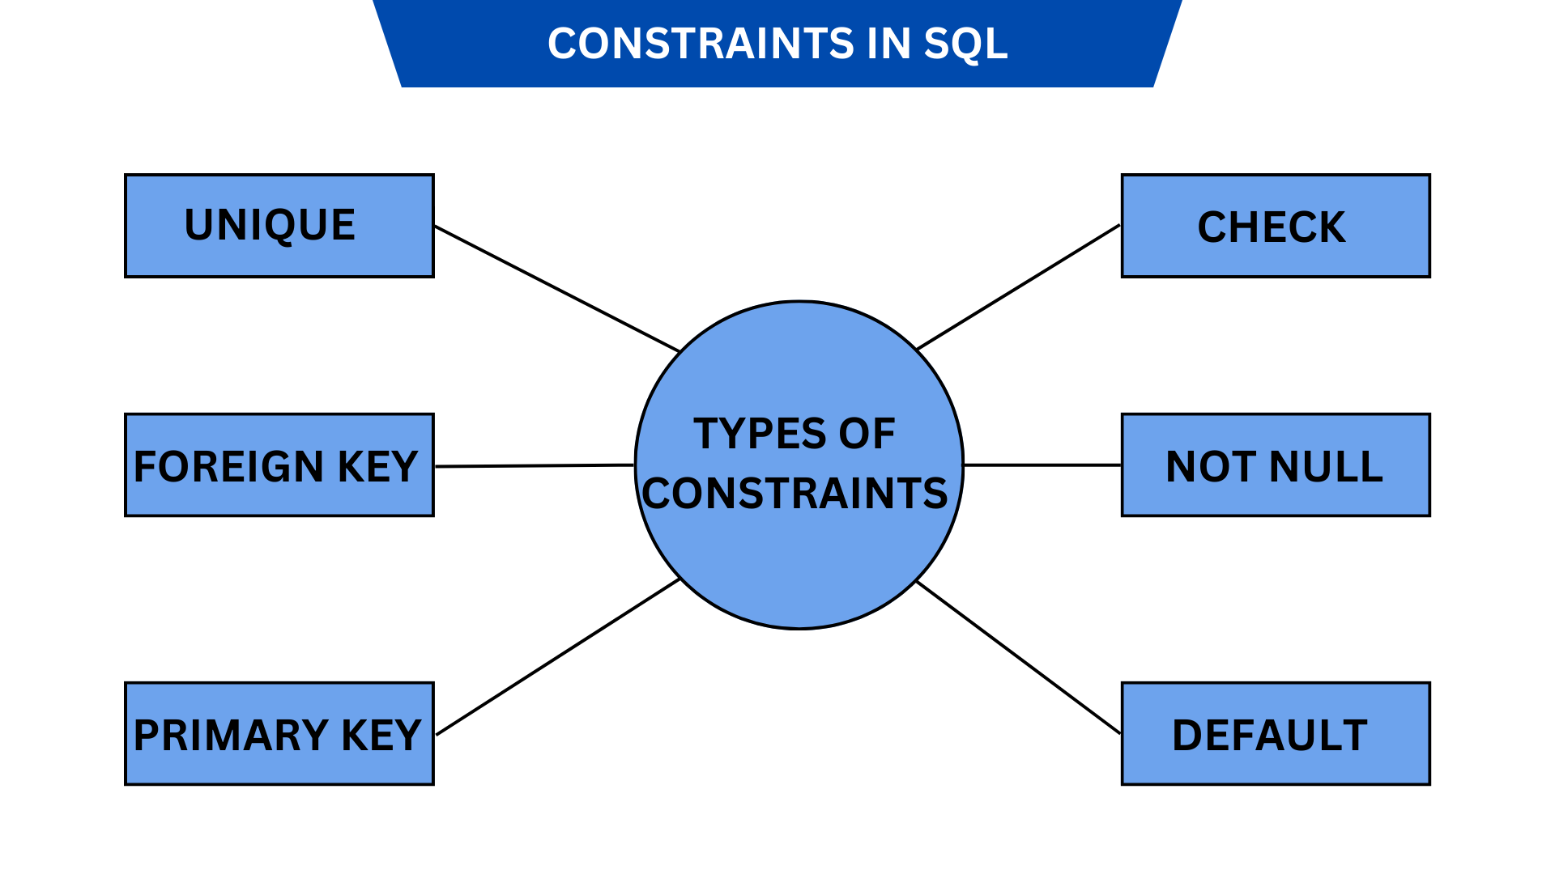

1. NOT NULL
- Ensures that a column cannot have a NULL value.
- Example: name VARCHAR(50) NOT NULL

2. UNIQUE
- Ensures that all values in a column are different.
- Example: email VARCHAR(100) UNIQUE

3. PRIMARY KEY
- Uniquely identifies each row in a table. Combines NOT NULL and UNIQUE.
- Example: id INT PRIMARY KEY

4. FOREIGN KEY
- Links two tables. Ensures that the value in one table exists in another.
- Example: dept_id INT, FOREIGN KEY (dept_id) REFERENCES departments(id)

5. CHECK
- Ensures that all values in a column satisfy a specific condition.
- Example: age INT CHECK (age >= 18)

6. DEFAULT
- Sets a default value for a column if no value is provided.
- Example: status VARCHAR(10) DEFAULT 'active'

7. AUTO_INCREMENT (in MySQL)
- Automatically increases the value of a numeric column.
- Example: id INT AUTO_INCREMENT PRIMARY KEY

- How do PRIMARY KEY and FOREIGN KEY constraints differ?

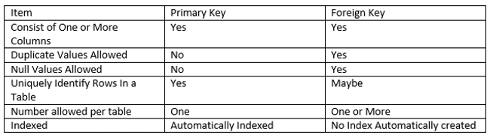

- What is the role of NOT NULL and UNIQUE constraints?

NOT NULL Constraint:
- Ensures that a column cannot have a NULL (empty) value.
- Every record must have some value in that column.

UNIQUE Constraint:
- Ensures that all values in a column are different (no duplicates allowed).
- Multiple NULLs are allowed (except in some DBMS).

Role summary:
- NOT NULL guarantees data presence (no missing values).
- UNIQUE guarantees data uniqueness (no repeated values).

- Main SQL Commands and Sub-commands (DDL):
Theory Questions:
- Define the SQL Data Definition Language (DDL).
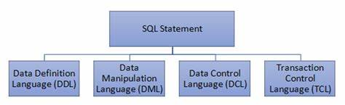

Common DDL Commands:
1. CREATE – To create new database objects (e.g., tables, views).
2. ALTER – To modify existing database structures.
3. DROP – To delete database objects.
4. TRUNCATE – To remove all records from a table (without deleting the table).
5. RENAME – To rename database objects.

Example:
sql
CREATE TABLE students (
id INT PRIMARY KEY,
name VARCHAR(50),
age INT
);

2. Explain the CREATE command and its syntax.
The *CREATE* command in SQL is used to create new database objects, such as:

- Tables
- Views
- Indexes
- Databases

---

Syntax for Creating a Table:

sql
CREATE TABLE table_name (
column1 datatype [constraint],
column2 datatype [constraint],
...
);

---

Example:

sql
CREATE TABLE employees (
emp_id INT PRIMARY KEY,
name VARCHAR(50) NOT NULL,
salary DECIMAL(10, 2),
department_id INT
);

---

Key Points:
- table_name: The name of the table you want to create.
- Each column is defined with a name, data type, and optional constraints like PRIMARY KEY, NOT NULL, etc.

This command defines the structure of the table but does not insert data into it.

3.What is the purpose of specifying data types and constraints during table creation?

1. Data Types
They define the kind of data a column can store, such as:

- INT → for integers
- VARCHAR(n) → for text
- DATE → for dates
- FLOAT, DECIMAL → for decimal numbers

✅ Why it's important:
- Ensures data is stored correctly
- Helps optimize storage and performance
- Prevents invalid data from being entered (e.g., text in a numeric field)

---

2. Constraints
They define rules for what kind of data is allowed in the column.

Common constraints:
- NOT NULL → column must have a value
- UNIQUE → no duplicate values
- PRIMARY KEY → unique + not null, used to identify rows
- FOREIGN KEY → creates a relationship between tables
- CHECK → restricts values based on a condition
- DEFAULT → sets a default value if none is provided

✅ Why it's important:
- Maintains data accuracy and integrity
- Avoids duplicate or missing data
- Enforces relationships between tables

In short:
Data types = what kind of data
Constraints = rules for that data

- ALTER Command:

Theory Questions:

- What is the use of the ALTER command in SQL?

The ALTER command in SQL is used to modify an existing table structure.

✅ Uses of ALTER command:

1. Add a new column
sql
ALTER TABLE table_name ADD column_name datatype;

2. Delete a column
sql
ALTER TABLE table_name DROP COLUMN column_name;

3. Modify a column's data type or size
sql
ALTER TABLE table_name MODIFY column_name new_datatype;

4. Rename a column (some databases)
sql
ALTER TABLE table_name RENAME COLUMN old_name TO new_name;

5. Rename the table
sql
ALTER TABLE old_table_name RENAME TO new_table_name;

6. Add or remove constraints (e.g., NOT NULL, UNIQUE, FOREIGN KEY, etc.)

---

🔍 Example:
sql
ALTER TABLE students ADD age INT;

Adds a new column age of type INT to the students table.

---

In short:
The ALTER command lets you change the structure of an existing table without deleting or recreating it.

- How can you add, modify, and drop columns from a table using ALTER?

✅ 1. Add a Column
Syntax:
sql
ALTER TABLE table_name ADD column_name datatype;

Example:
sql
ALTER TABLE students ADD email VARCHAR(100);

This adds a new column email to the students table.

---

✅ 2. Modify a Column
Syntax (varies by DBMS):
sql
ALTER TABLE table_name MODIFY column_name new_datatype;
-- OR --
ALTER TABLE table_name ALTER COLUMN column_name TYPE new_datatype;

Example (MySQL):
sql
ALTER TABLE students MODIFY email VARCHAR(150);

Example (PostgreSQL):
sql
ALTER TABLE students ALTER COLUMN email TYPE VARCHAR(150);

This changes the data type or size of the email column.

---

✅ 3. Drop a Column
Syntax:
sql
ALTER TABLE table_name DROP COLUMN column_name;

Example:
sql
ALTER TABLE students DROP COLUMN email;

This removes the email column from the students table.

- DROP Command:

Theory Questions:
- What is the function of the DROP command in SQL?

🔹 Function of DROP:
- Completely removes the object from the database.
- Deletes structure + all data inside the object.
- This action cannot be undone.

---

🔸 Common Usage Examples:

1. Drop a Table:
sql
DROP TABLE table_name;

Deletes the entire table and its data.

2. Drop a Database:
sql
DROP DATABASE database_name;

Removes the whole database.

3. Drop a Column (in some DBMS):
sql
ALTER TABLE table_name DROP COLUMN column_name;

- What are the implications of dropping a table from a database?

🔻 Implications of Dropping a Table:

1. Permanent Deletion:
- The table and all its data are permanently deleted.
- You cannot recover the data unless you have a backup.

2. Loss of Structure:
- The table schema (columns, data types, constraints) is lost.
- You’ll need to redefine the table if you want it back.

3. Dependent Objects Affected:
- Any views, stored procedures, triggers, or foreign keys that depend on the table may also be invalidated or fail.
- Could cause errors in application logic.

4. Breaks Relationships:
- If the table is referenced by foreign keys, dropping it may lead to referential integrity issues.

5. No Confirmation (in many systems):
- Some databases drop tables without asking for confirmation, so accidental drops can be dangerous.

---

✅ Recommendation:
- Use DROP TABLE only when you're sure you don't need the table or its data.
- Prefer TRUNCATE or DELETE if you just want to remove data but keep the structure.

---

Example:
sql
DROP TABLE employees;

This command will delete the employees table completely—structure and all data gone.
- Data Manipulation Language (DML)

Theory Questions:

- Define the INSERT, UPDATE, and DELETE commands in SQL.
1. INSERT
Purpose: Adds new records (rows) into a table.

Syntax:
sql
INSERT INTO table_name (column1, column2, ...)
VALUES (value1, value2, ...);

Example:
sql
INSERT INTO students (name, age)
VALUES ('Rahul', 21);

---

2. UPDATE
Purpose: Modifies existing records in a table.

Syntax:
sql
UPDATE table_name
SET column1 = value1, column2 = value2, ...
WHERE condition;

Example:
sql
UPDATE students
SET age = 22
WHERE name = 'Rahul';

> ⚠ Use WHERE carefully to avoid updating all rows by mistake.

---

3. DELETE
Purpose: Deletes one or more existing records from a table.

Syntax:
sql
DELETE FROM table_name
WHERE condition;

Example:
sql
DELETE FROM students
WHERE name = 'Rahul';

> ⚠ Without WHERE, all records will be deleted from the table.

- What is the importance of the WHERE clause in UPDATE and DELETE operations?

Why is it important?

- Without WHERE, all rows in the table will be affected.
- With WHERE, only specific rows matching the condition will be affected.

---

✅ With WHERE (Safe)

Example:
sql
DELETE FROM students
WHERE id = 101;

*→ Only the student with id = 101 will be deleted.*

---

❌ Without WHERE (Dangerous)

Example:
sql
DELETE FROM students;

→ Deletes *all students from the table!*

---

Summary:

| Clause Used | Result |
|-------------|----------------------------------|
| With WHERE | Only matching rows affected |
| Without WHERE | All rows affected (risky!) |

Conclusion: Always use WHERE carefully in UPDATE and DELETE to avoid accidental data loss.

8. Data Query Language (DQL)
Theory Questions:

- What is the SELECT statement, and how is it used to query data?
The *SELECT statement* in SQL is used to query (retrieve) data from one or more tables in a database.

---

Basic Syntax:
sql
SELECT column1, column2, ...
FROM table_name
WHERE condition;

---

How it's used:

1. Select specific columns:
sql
SELECT name, age FROM students;

→ Retrieves name and age columns from the students table.

2. Select all columns:
sql
SELECT * FROM students;

→ Retrieves all columns for all students.

3. With a condition:
sql
SELECT * FROM students WHERE age > 18;

→ Retrieves students whose age is greater than 18.

---

Key Points:
- SELECT is the most commonly used SQL command.
- It’s used for reading data only (no changes to the table).
- Can be combined with clauses like WHERE, ORDER BY, GROUP BY, etc.

- Explain the use of the ORDER BY and WHERE clauses in SQL queries.

*WHERE Clause:*
- The WHERE clause is used to filter rows based on a condition.
- Only rows that satisfy the condition will be included in the result.

Example:
sql
SELECT * FROM students WHERE age > 18;

➡ Shows only students older than 18.

---

*ORDER BY Clause:*
- The ORDER BY clause is used to sort the result by one or more columns.
- You can sort in *ascending (ASC)* or *descending (DESC)* order.

Example:
sql
SELECT * FROM students ORDER BY name ASC;

➡ Shows all students, sorted by name alphabetically.

---

Both Together:
sql
SELECT * FROM students
WHERE age > 18
ORDER BY name DESC;

➡ Shows students older than 18, sorted by name in reverse alphabetical order.

---

Summary:
- *WHERE* = filters data
- *ORDER BY* = sorts data

9.Data Control Language (DCL)

Theory Questions:

- What is the purpose of GRANT and REVOKE in SQL?

1. GRANT
Used to give permissions to users for performing specific operations on database objects (like tables, views, etc.).

Syntax:
sql
GRANT privilege_name ON object_name TO user_name;

Example:
sql
GRANT SELECT, INSERT ON employees TO user1;

➡ This allows user1 to view (SELECT) and add (INSERT) data to the employees table.

---

2. REVOKE
Used to take back permissions that were previously granted.

Syntax:
sql
REVOKE privilege_name ON object_name FROM user_name;

Example:
sql
REVOKE INSERT ON employees FROM user1;

➡ This removes the INSERT permission from user1.

---

In Short:
- GRANT = Allow access
- REVOKE = Remove access
They help secure and control who can do what in your database.

- How do you manage privileges using these commands?

Privilege management can mean different things depending on the context:
- In Linux/Unix systems → chmod, chown, chgrp, umask, and sudo are used to manage file/user privileges.
- In Databases (like MySQL/SQL Server/Oracle) → GRANT, REVOKE, and DENY are used to manage user privileges.
- In Windows → icacls, net user, and group policy commands are used.

--> If you show me the specific commands you’re studying (maybe from your module/notes), I can explain how privileges are managed with them step by step.
Do you mean Linux commands (chmod, chown, umask) or SQL commands (GRANT, REVOKE)?

10. Transaction Control Language (TCL):

Theory Questions:

- What is the purpose of the COMMIT and ROLLBACK commands in SQL?

COMMIT and ROLLBACK are used to manage transactions in SQL.

- COMMIT: Saves all the changes made in the current transaction permanently to the database.
Purpose: Make changes final and visible to others.

- ROLLBACK: Undoes all changes made in the current transaction, reverting the database to its previous state.
Purpose: Cancel changes if something goes wrong or if you want to discard changes.

---

Example:
- You insert some rows, then use COMMIT to save them.
- If there’s an error, you use ROLLBACK to undo those inserts.

---

In short:
- COMMIT = Save changes
- ROLLBACK = Undo changes

- Explain how transactions are managed in SQL databases.

🔹 Transaction in SQL
A transaction = group of SQL operations treated as one unit.
🔹 Properties (ACID)
- Atomicity → all or nothing
- Consistency → valid state to valid state
- Isolation → transactions don’t interfere
- Durability → once saved, permanent
🔹 Commands
- START TRANSACTION → begin
- COMMIT → save permanently
- ROLLBACK → undo changes
- SAVEPOINT → mark a checkpoint
👉 Example: In a bank transfer, both debit & credit must succeed; otherwise, rollback ensures no money is lost.

11. SQL Joins:

Theory Questions:

  - Explain the concept of JOIN in SQL. What is the difference between INNER JOIN, LEFTJOIN, RIGHT JOIN, and FULL OUTER JOIN?

1. INNER JOIN
- Returns only the rows where there is a match in both tables.
- If no match, that row is not included.

2. LEFT JOIN (or LEFT OUTER JOIN)
- Returns all rows from the left table and matched rows from the right table.
- If no match in the right table, result shows NULL for right table columns.

3. RIGHT JOIN (or RIGHT OUTER JOIN)
- Returns all rows from the right table and matched rows from the left table.
- If no match in the left table, result shows NULL for left table columns.

4. FULL OUTER JOIN
- Returns all rows when there is a match in either left or right table.
- If no match, shows NULLs on the side where there's no match

  - How are joins used to combine data from multiple tables?

Joins in SQL are used to combine rows from two or more tables based on a related column between them, usually using primary and foreign key relationships.

---

How Joins Work:

Joins compare the values of a common column (like id or user_id) and return rows that match certain conditions depending on the join type.

---

Common Types of Joins:

1. INNER JOIN
- Returns only matching rows from both tables.
- Example: Get only users who placed orders.
sql
SELECT users.name, orders.amount
FROM users
INNER JOIN orders ON users.id = orders.user_id;

2. LEFT JOIN (or LEFT OUTER JOIN)
- Returns all rows from the left table, and matching rows from the right table (if any).
- If no match, NULLs are returned from the right table.
sql
SELECT users.name, orders.amount
FROM users
LEFT JOIN orders ON users.id = orders.user_id;

3. RIGHT JOIN (or RIGHT OUTER JOIN)
- Opposite of LEFT JOIN.
- Returns all rows from the right table, and matching rows from the left table.

4. FULL OUTER JOIN
- Returns all rows when there is a match in either table.
- If there’s no match, NULLs are shown for missing data.

12. SQL Group By:

Theory Questions:

- What is the GROUP BY clause in SQL? How is it used with aggregate functions?
GROUP BY clause in SQL is used to group rows that have the same values in one or more columns. It's mainly used with aggregate functions like:

- COUNT()
- SUM()
- AVG()
- MAX()
- MIN()

Purpose:
To perform calculations on groups of data, not just individual rows.

---

Syntax:
sql
SELECT column_name, AGGREGATE_FUNCTION(column_name)
FROM table_name
GROUP BY column_name;

---

Example:
Suppose we have a table Sales:

| Customer | Amount |
|----------|--------|
| A | 100 |
| B | 200 |
| A | 150 |
| B | 300 |

Now we want total sales per customer:

sql
SELECT Customer, SUM(Amount)
FROM Sales
GROUP BY Customer;

Output:

| Customer | SUM(Amount) |
|----------|-------------|
| A | 250 |
| B | 500 |

- Explain the difference between GROUP BY and ORDER BY.
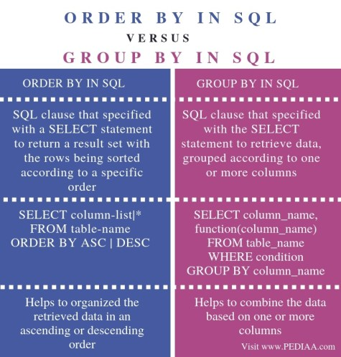
13. SQL Stored Procedure:

Theory Questions:

- What is a stored procedure in SQL, and how does it differ from a standard SQL query?

Stored Procedure (in short):
A stored procedure is a saved set of SQL commands that you can reuse. It accepts parameters, supports logic (like IF/WHILE), and is faster for repeated tasks.

Difference from SQL Query:
- SQL Query: One-time, simple command.
- Stored Procedure: Predefined, reusable, can take inputs, and perform complex logic.

2. Explain the advantages of using stored procedures.

Advantages of Using Stored Procedures:

1. Reusability: Write once, use many times.
2. Improved Performance: Compiled and stored in the database.
3. Security: Can restrict direct access to tables.
4. Maintainability: Easier to update logic in one place.
5. Reduced Network Traffic: Executes on the server, not client-side.
6. Modularity: Breaks complex tasks into smaller, manageable blocks.

14. SQL View

Theory Questions:

- What is a view in SQL, and how is it different from a table?
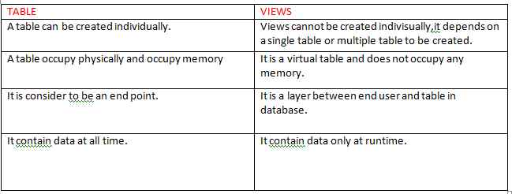

- Explain the advantages of using views in SQL databases

Advantages of Using Views in SQL:

1. Simplifies Complex Queries:
- You can write complex joins or filters once in a view, then use the view as a simple table in future queries.

2. Improves Security:
- Views can restrict access to specific columns or rows in a table, helping control what users can see.

3. Data Abstraction:
- Users can interact with the data without knowing the underlying table structure.

4. Reusability:
- Views can be reused in multiple queries, reducing duplication of SQL code.

5. Logical Data Independence:
- Changes in table structure may not affect users if they interact through views.

6. Better Readability:
- Makes queries cleaner and more readable by encapsulating logic inside the view.

7. Real-Time Data:
- Views always show the latest data from the underlying tables.

Example:
If you only want HR staff to see names and designations of employees:

sql
CREATE VIEW HR_View AS
SELECT name, designation FROM Employees;

15. SQL Triggers:

Theory Questions:

- What is a trigger in SQL? Describe its types and when they are used.

What is a Trigger in SQL?
A trigger is a special type of stored procedure that automatically executes (fires) in response to certain events on a table or view, such as INSERT, UPDATE, or DELETE operations.

---

Types of Triggers in SQL:

1. BEFORE Trigger
- Executes before the triggering action (INSERT/UPDATE/DELETE).
- Use: To validate or modify data before it is saved.

2. AFTER Trigger
- Executes after the triggering action.
- Use: To log actions, update related tables, etc.

3. INSTEAD OF Trigger (mostly in views)
- Replaces the triggering action.
- Use: When you want custom behavior instead of the default action.

---

When Triggers Are Used:

- Enforcing complex business rules
- Auditing changes (who did what and when)
- Validating or modifying data automatically
- Maintaining related tables, like updating stock after a sale

---

Example:
sql
CREATE TRIGGER trg_after_insert
AFTER INSERT ON Employees
FOR EACH ROW
BEGIN
INSERT INTO AuditLog (action, emp_id, action_time)
VALUES ('INSERT', NEW.id, NOW());
END;

- Explain the difference between INSERT, UPDATE, and DELETE triggers.
Here’s the difference between INSERT, UPDATE, and DELETE triggers in SQL, explained simply:

---

1. INSERT Trigger
- When it fires: When a new row is inserted into a table.
- Use: To take automatic actions when data is added.
- Example use case: Log every new user registration.

sql
AFTER INSERT ON Users

---

2. UPDATE Trigger
- When it fires: When an existing row is updated.
- Use: To track changes or validate updates.
- Example use case: Save old values before updating salary.

sql
AFTER UPDATE ON Employees

---

3. DELETE Trigger
- When it fires: When a row is deleted from a table.
- Use: To archive or log data before it's permanently removed.
- Example use case: Store deleted orders in a backup table.

sql
BEFORE DELETE ON Orders

---

Key Differences:

| Trigger Type | When It Executes | Common Usage |
|--------------|----------------------|----------------------------------|
| INSERT | On new data entry | Audit/log additions |
| UPDATE | On data modification | Validate or log changes |
| DELETE | On data removal | Backup or prevent accidental loss|

16. Introduction to PL/SQL

Theory Questions:

- What is PL/SQL, and how does it extend SQL's capabilities?
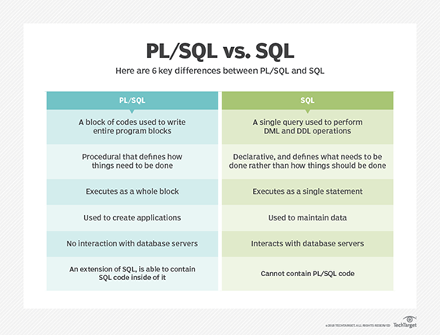

PL/SQL is an extension of SQL used in Oracle that adds programming features like:

- Variables
- Loops
- Conditions (if-else)
- Error handling
- Functions & Procedures

SQL only handles queries, while PL/SQL lets you write complete programs inside the database.

In short:
PL/SQL = SQL + Logic + Control + Reusability
Used to build complex and secure database applications.
- List and explain the benefits of using PL/SQL.

1. Block Structure:
- Code is written in logical blocks (DECLARE, BEGIN, EXCEPTION, END).
- Easy to read, debug, and manage.

2. Tight Integration with SQL:
- SQL can be used directly inside PL/SQL blocks.
- No need for separate processing.

3. Procedural Capabilities:
- Supports variables, loops, conditions (if-else), etc.
- Enables complex business logic.

4. Improved Performance:
- PL/SQL code runs inside the database engine.
- Reduces multiple SQL calls (network round trips).

5. Security:
- Logic is stored in the database, not in external applications.
- Can restrict direct access to tables using procedures or functions.

6. Error Handling:
- Built-in EXCEPTION handling for managing run-time errors gracefully.

7. Portability:
- PL/SQL code can run on any Oracle database without changes.

8. Reusability:
- You can create stored procedures, functions, triggers, and packages.
- Reuse them across multiple applications.

17. PL/SQL Control Structures

Theory Questions:

1. What are control structures in PL/SQL? Explain the IF-THEN and LOOP control structures.
Control structures in PL/SQL are used to control the flow of execution in a program, just like in other programming languages. They include:

---

1. IF-THEN Control Structure
Used for decision-making based on conditions.

Syntax:
sql
IF condition THEN
-- statements
END IF;

Variants:
- IF...THEN
- IF...THEN...ELSE
- IF...THEN...ELSIF...ELSE

Example:
sql
DECLARE
marks NUMBER := 75;
BEGIN
IF marks >= 50 THEN
DBMS_OUTPUT.PUT_LINE('Pass');
ELSE
DBMS_OUTPUT.PUT_LINE('Fail');
END IF;
END;

---

2. LOOP Control Structures
Used to execute a block of code repeatedly.

a. Simple LOOP
sql
LOOP
-- statements
EXIT WHEN condition;
END LOOP;

b. WHILE LOOP
sql
WHILE condition LOOP
-- statements
END LOOP;

c. FOR LOOP
sql
FOR i IN 1..5 LOOP
-- statements
END LOOP;

Example:
sql
BEGIN
FOR i IN 1..5 LOOP
DBMS_OUTPUT.PUT_LINE('Count: ' || i);
END LOOP;
END;

2. How do control structures in PL/SQL help in writing complex queries?

Control structures in PL/SQL help write complex queries by allowing you to add logic and decision-making inside the database operations. Instead of just running simple queries, you can:

- Make decisions with IF-THEN to run different code based on conditions (like checking values before updating).
- Repeat actions with loops to process multiple rows or perform repeated calculations.
- Handle errors and exceptions to make your program robust.
- Control flow in stored procedures and functions, enabling complex business logic inside the database.

This means you can automate, customize, and manage data operations much more flexibly and powerfully than with plain SQL alone.

18. SQL Cursors

Theory Questions:

1. What is a cursor in PL/SQL? Explain the difference between implicit and explicit cursors.

A cursor in PL/SQL is a pointer that allows you to fetch and process query results row by row. It helps manage the result set of a query inside a PL/SQL program.

Types of Cursors:

1. Implicit Cursor
- Automatically created by PL/SQL when you run a SELECT, INSERT, UPDATE, or DELETE statement that returns only one row.
- You don’t need to declare or manage it explicitly.
- Used for simple queries.
- Example: When you do SELECT INTO in PL/SQL.

2. Explicit Cursor
- Declared and controlled by the programmer.
- Used when a query returns multiple rows.
- You open the cursor, fetch rows one by one, and then close it.
- Gives more control over row-by-row processing.

Summary:
- Implicit cursor: Automatic, simple, for single-row queries.
- Explicit cursor: Programmer-controlled, for multi-row queries, more flexible.

2. When would you use an explicit cursor over an implicit one?

- You need to process multiple rows returned by a query one at a time.
- You want more control over fetching, processing, and managing rows.
- You need to perform complex logic on each row individually.
- You want to open, fetch, and close the cursor manually.
- Implicit cursors can only handle single-row queries, so for multi-row queries, explicit cursors are necessary.

In short: Use explicit cursors when dealing with queries that return multiple rows and you want to handle each row separately.

19. Rollback and Commit Savepoint

Theory Questions:
- Explain the concept of SAVEPOINT in transaction management. How do ROLLBACK and COMMIT interact with savepoints?
SAVEPOINT in transaction management is like a bookmark within a transaction. It lets you mark a specific point so you can rollback to that point without undoing the entire transaction.

- SAVEPOINT creates a named point inside a transaction.
- You can ROLLBACK TO SAVEPOINT to undo only the changes made after that savepoint.
- COMMIT will save all changes made in the transaction, including after the savepoints.
- If you do a normal ROLLBACK without specifying a savepoint, it undoes the whole transaction.

Example:

1. Start transaction
2. SAVEPOINT A
3. Make some changes
4. SAVEPOINT B
5. Make more changes
6. ROLLBACK TO SAVEPOINT A → undoes changes after A but keeps changes before it
7. COMMIT → saves all changes made till now

In short: Savepoints let you partially undo within a transaction, giving more control before the final commit.

- When is it useful to use savepoints in a database transaction?

Savepoints are useful when you want more control over complex transactions, especially when:

1. Partial rollback: You want to undo only some steps without canceling the whole transaction.
2. Error handling: If an error occurs in the middle, you can rollback to a safe point instead of starting over.
3. Long transactions: When many operations happen, savepoints let you checkpoint progress.
4. Nested transactions simulation: Since most DBMS don’t support nested transactions, savepoints help mimic that behavior.
5. Complex business logic: When multiple steps must succeed individually but still be part of one bigger transaction.

In short, savepoints help manage errors and partial failures smoothly inside big transactions.

